**CS584 Assignment 1: Report**

**Jingyu Zhu A20311779**

**1. Problem statement**

In this assignment, I tried to do various kinds of solutions for both single feature and multiple feature data sets. In respect of the single feature data sets, I managed to apply linear model and several polynomial models for fitting the data, with which I got the training error and testing error and then compared them with the errors given by the built-in lm() operation. Also, I have reduced the amount of training data and recorded the related errors. I kept recording the errors all the time and tried to figure out how the errors would change among different cases. With regards to the multiple feature data sets, I performed both the linear regression and high dimensional regression and compared their errors and performance. After that, I came up with an iterative solution to find out what’s the difference between the errors given by the explicit solution and those from the iterative one.

**2. Proposed solution**

In terms of the explicit solution, first I built the Z matrix based on all the given features. Then I plugged it into the following formula,



That gave me all the parameters I needed.

Then, I was able to get the Min Square Error (MSE) and the Relative Square Error (RSE) by following:

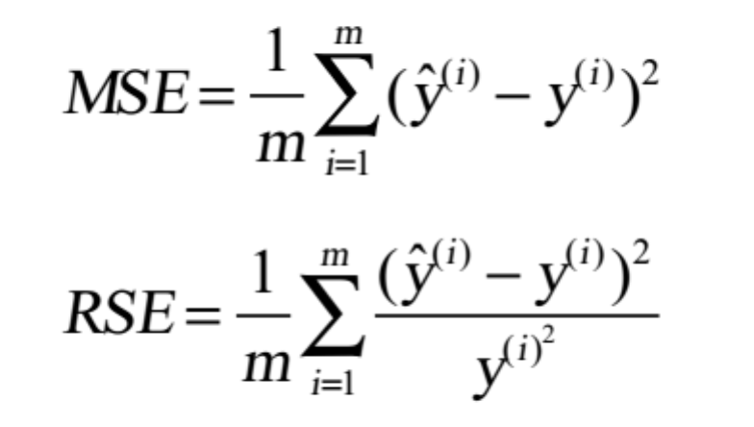

To come up with the iterative solution, I applied the gradient descent algorithm. The idea of the algorithm is: first, start with a guess “theta0”. Second, we iteratively update the guess “theta(i)” using data. The following formula properly summarize the foregoing process:



**3. Implementation details**

(1) Single variable regression

First, I opened the data file and got the data I needed. Second, I cut out all the feature columns and combined it with a new column <1, 1, … , 1> on the left side, by which I get the “Z” matrix. Also, I pull out the last column from the data to form the Y vector. Then I was able to calculate the theta vector by the formula mentioned above and figure out what the MSE and RSE are. After that I applied the built-in lm() function to come up with the “theta” once again and redid the process to calculate MSE and RSE one more time. Finally, I recorded these data in the “finalMatrix” and compared them.

To do the polynomial regression for the single variable data set, basically I just repeated the process I went through for the linear regression model. The only difference lied in constructing the Z matrix. Besides the all-one column, I also added a new quadratic column (for the cubic model, both the quadratic and cubic column) into the matrix. The other part before getting the final result was just the same as that in the linear regression model.

In the last step I’m with the single variable data sets, I cut all the four original data sets by half and reran my algorithm again to observe how the errors would change.

(2) Multivariate regression

First, I got the data from the files and mapped them to high dimensions. Then I constructed the high-dimension Z matrix. Second, I came up with the theta vector by the formula (which is mentioned in part2). Finally, I calculated the MSE and RSE, and recorded them.

To implement the iterative solution, I applied the Gradient Descent Algorithm. For the first two sets, I set the learning rate be 0.05 and then have the program iterated 1000 times to converge. For the latter two data sets, since the size of them were relatively large (100000 observations!), I decided to increase the learning rate up to 0.1 and reduce the number of iterations down to 300. At last, I put the result calculated by the iterative solution in a matrix. It turned out to be the algorithm worked pretty well with the parameters I provided.

The last step with the multivariate data sets was to solve the dual linear regression problem via a Gaussian kernel function. Therefore, I constructed my Gaussian kernel function (which can measure the similarity between vectors), and plugged in the data to get the final result. The codes gave more implementation details.

**4. Results and discussion**

***Single variable regression:***

1.Plot the data.

Data svar-set 1:

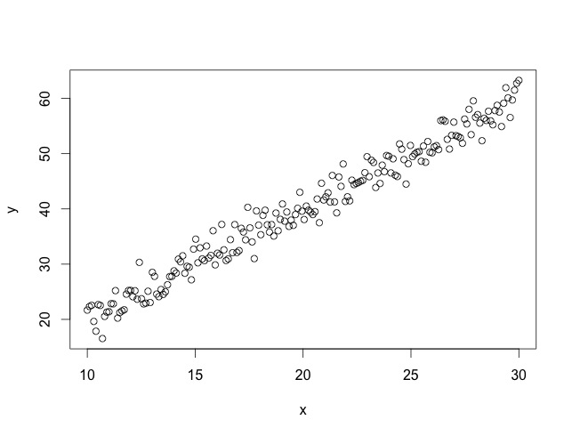

Data svar-set 2:

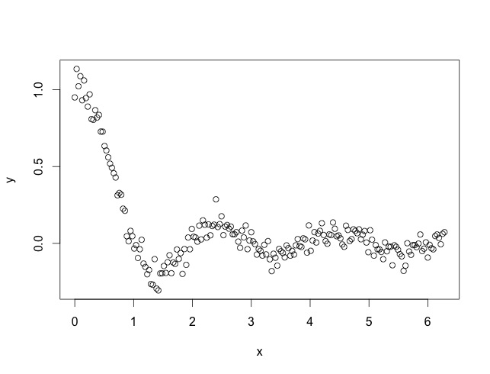

Data svar-set 3:

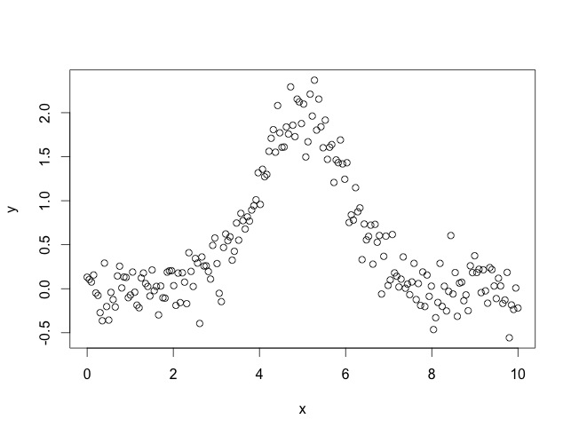

Data set 4:

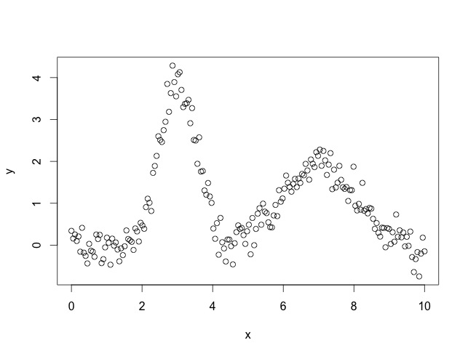

As we can see from the graphs above, it turns out that data set 1 should be fitted into a linear model, whereas the polynomial model might be proper for the other three data sets.

2. Fit the linear model for these data sets.

Since the 10 fold cross validation is applied, all the graphs show a result of ten groups.

***Attention: The four columns from the right are computed by the built-in lm() function.***

***Attention: After executing the programs, the calculated matrix of various errors (i.e. the training MSE RSE and the testing MSE RSE ) are stored in the variable “finalMatrix”.***

Data svar1:

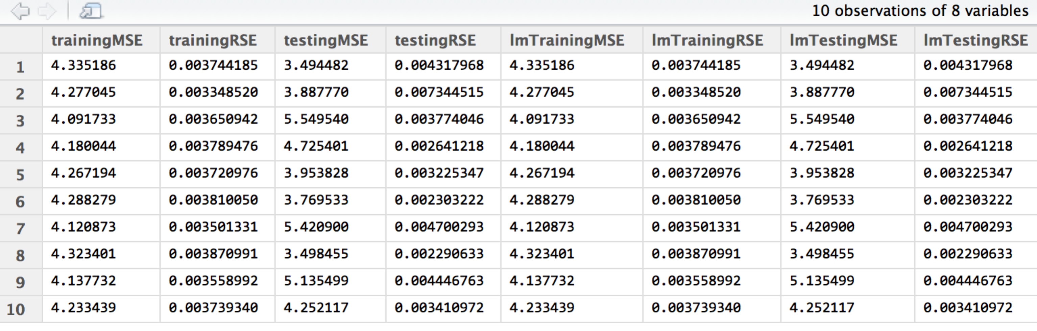

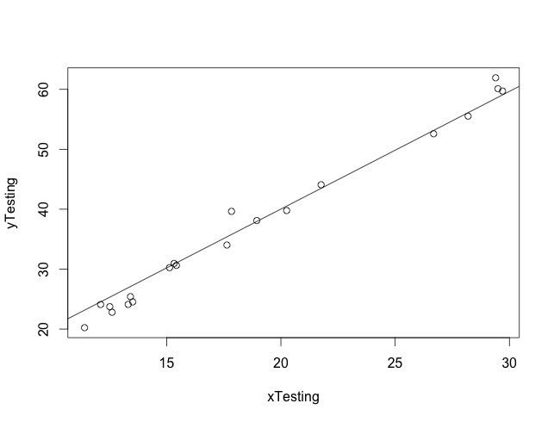

Data svar2:

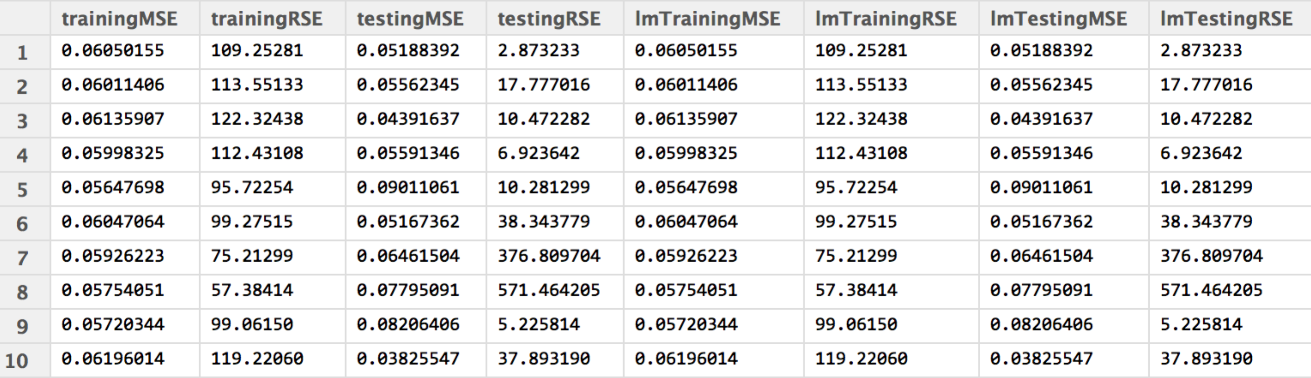

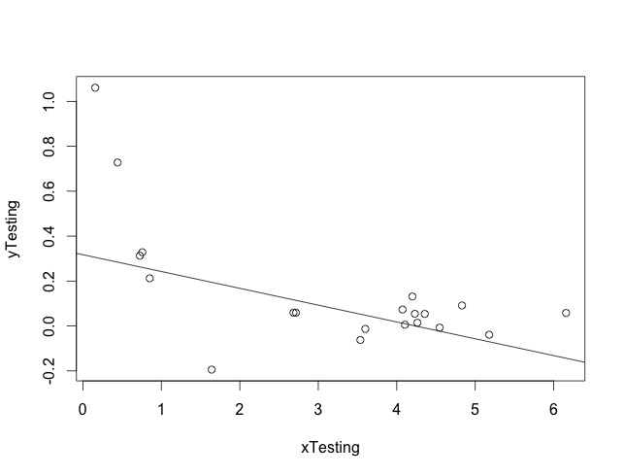

Data svar3:

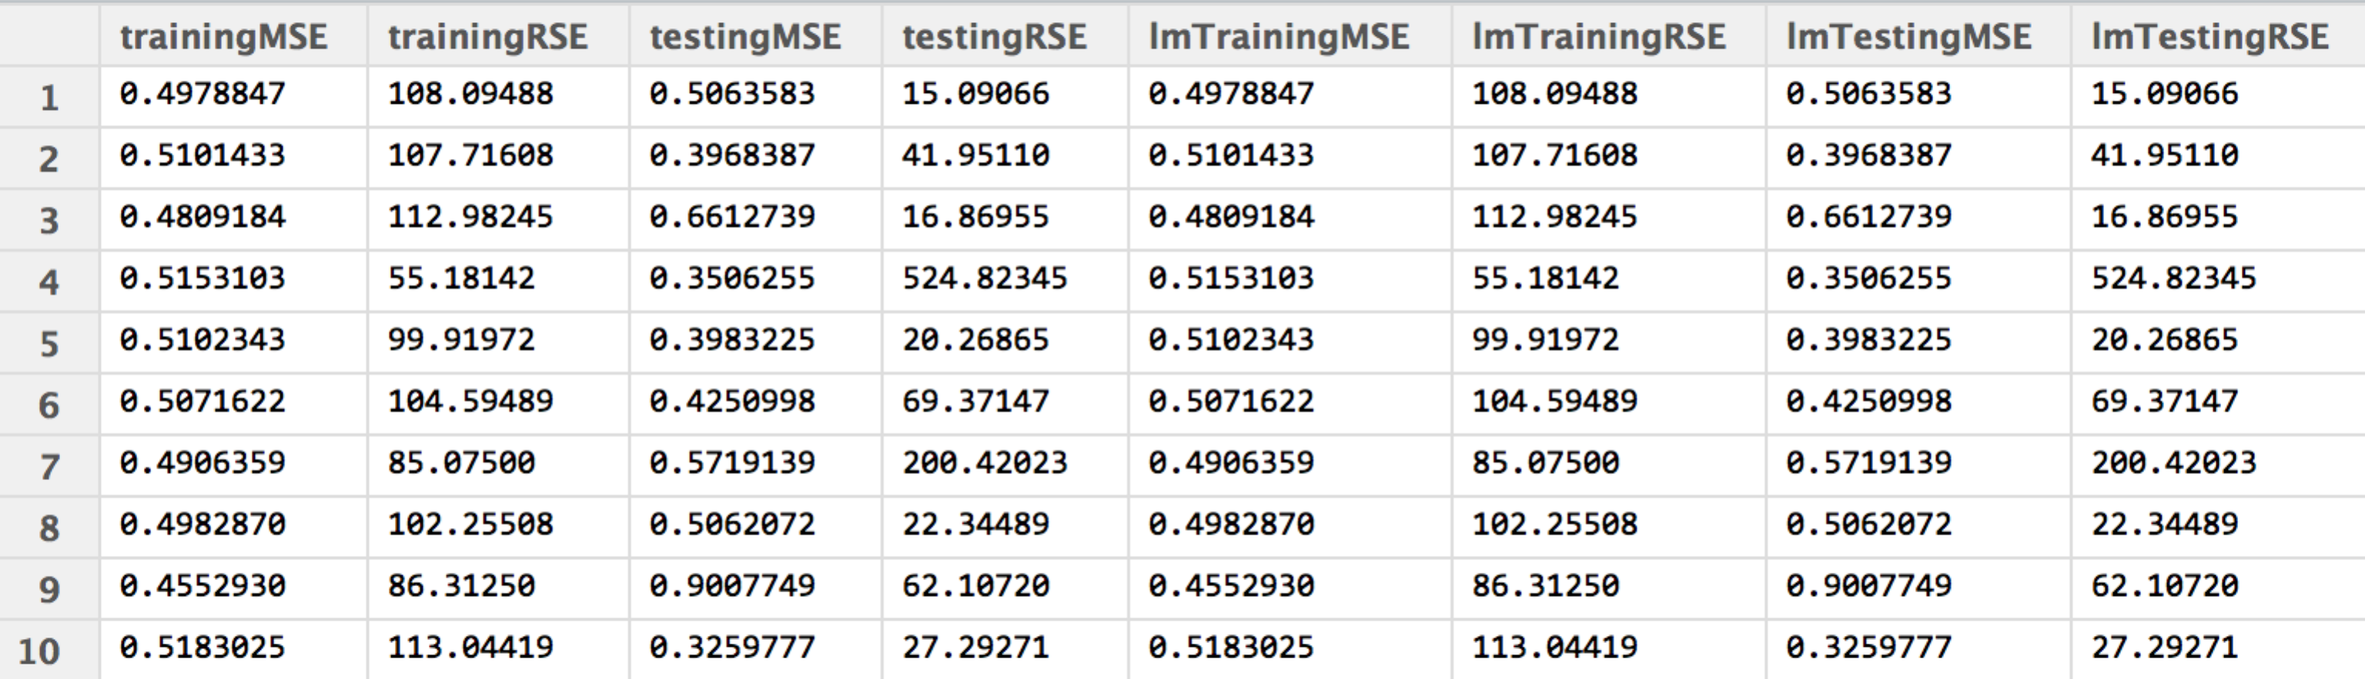

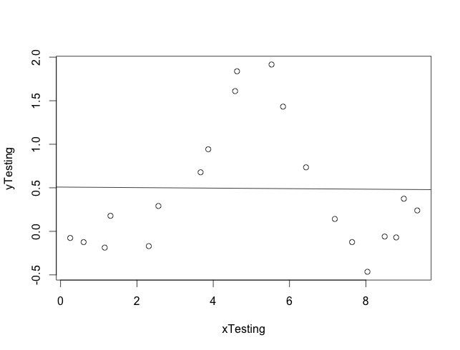

Data svar4:

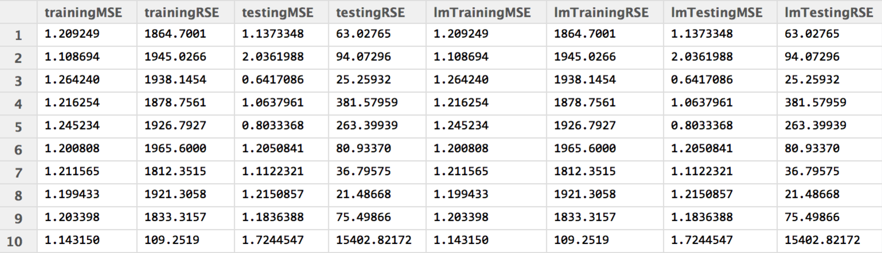

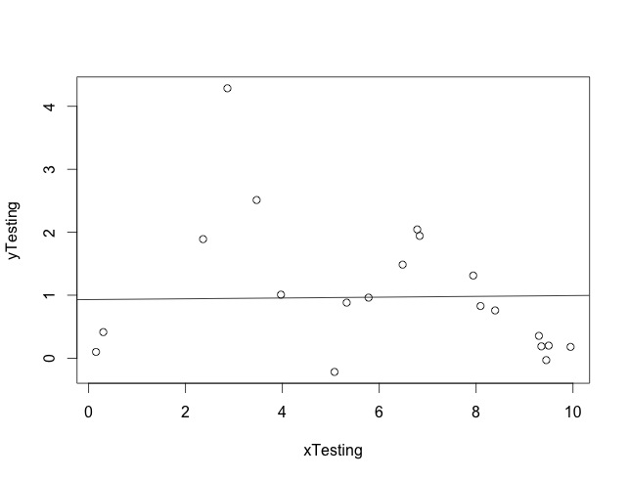

To conclude from above, MSE is not a good criterion to judge our regression model’s performance sometimes (as is shown from “svar2”). By contrast, typically RSE is a more powerful measurement and can give us better intuition about how far the data is fitted into the model.

3. Fit different polynomial models for these data sets.

Data svar1 quadratic model:

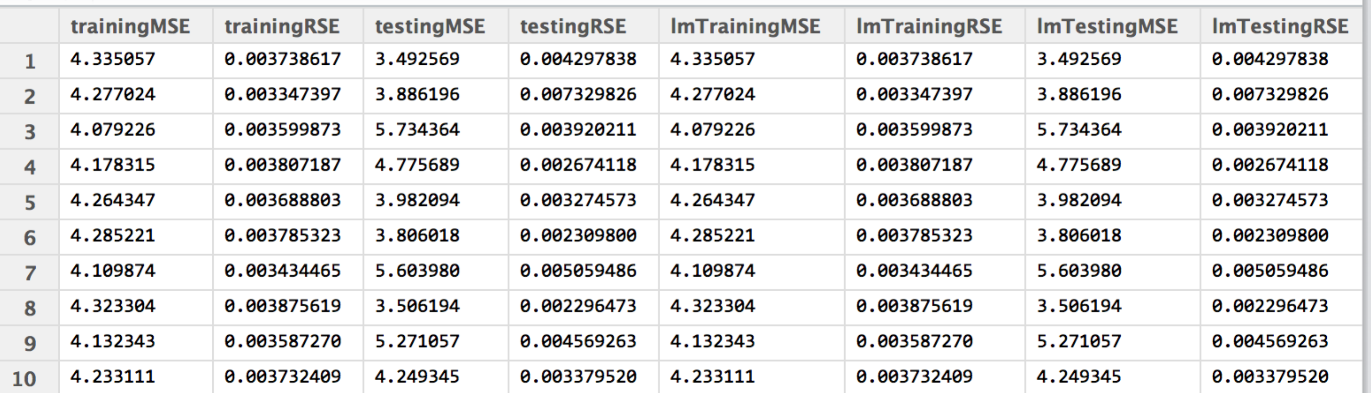

Data svar2 quadratic model:

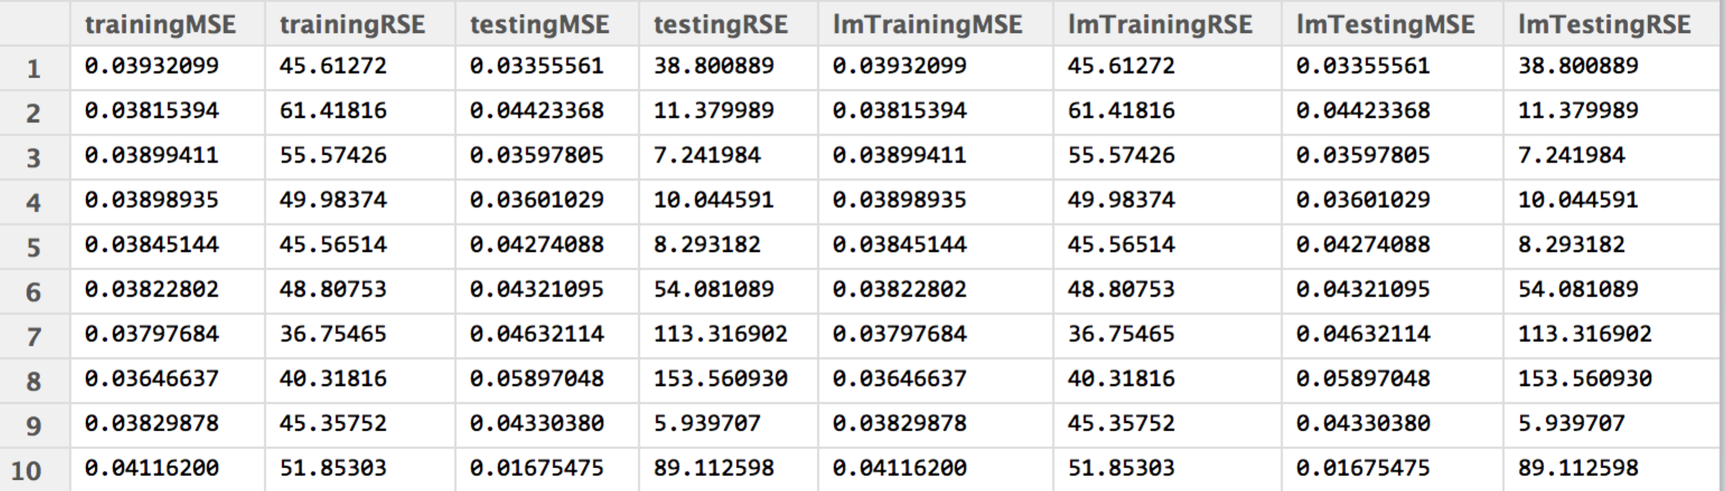

Data svar3 quadratic model:

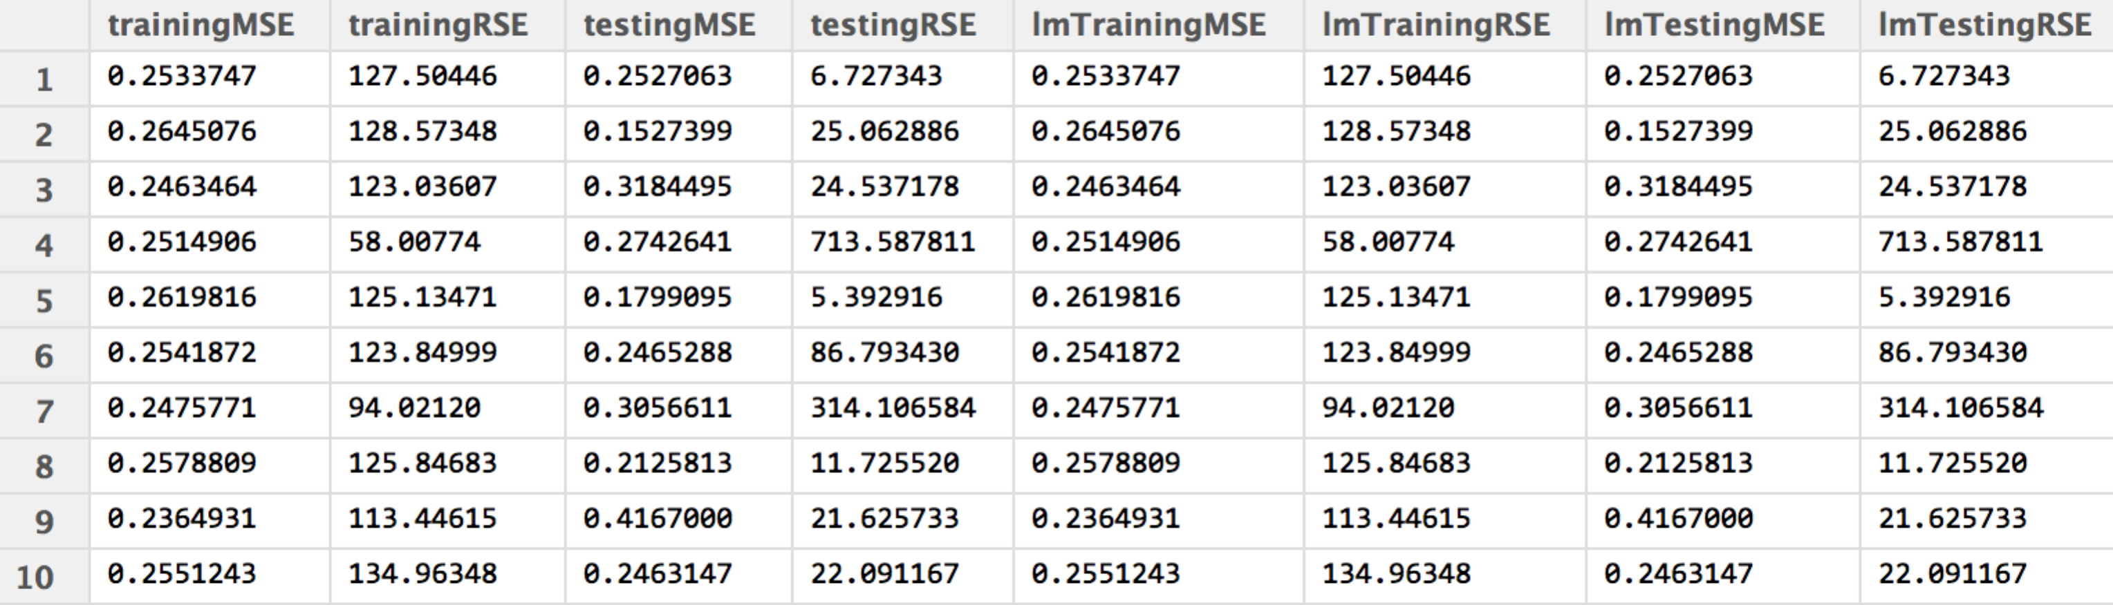

Data svar4 quadratic model:

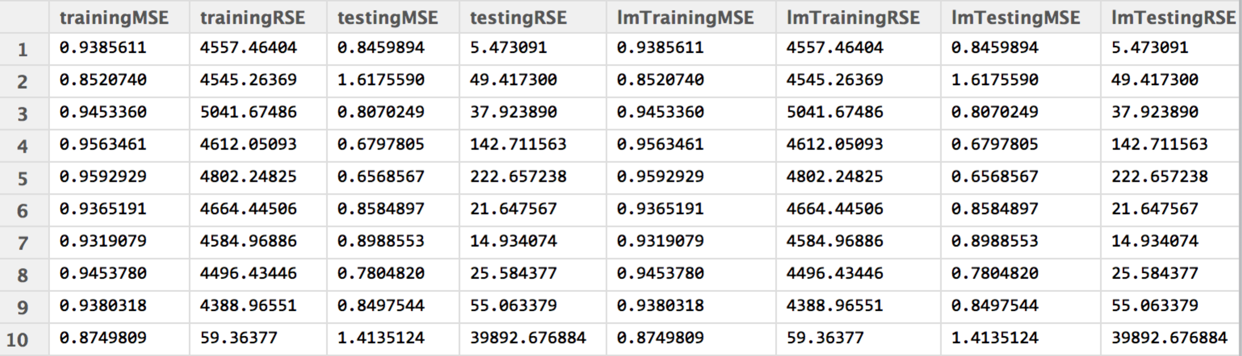

Data svar1 cubic model:

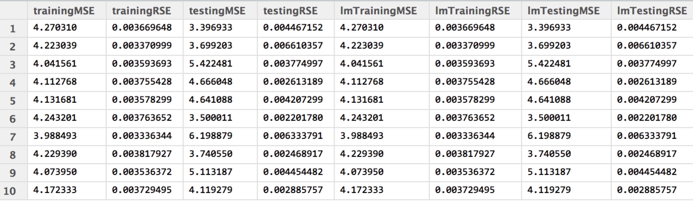

Data svar2 cubic model:

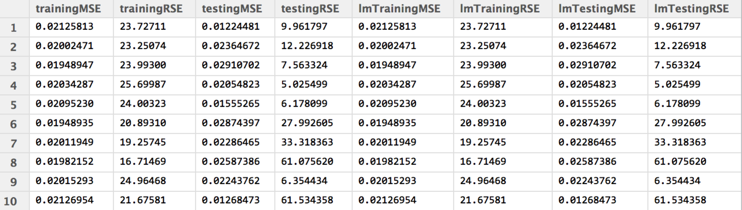

Data svar3 cubic model:

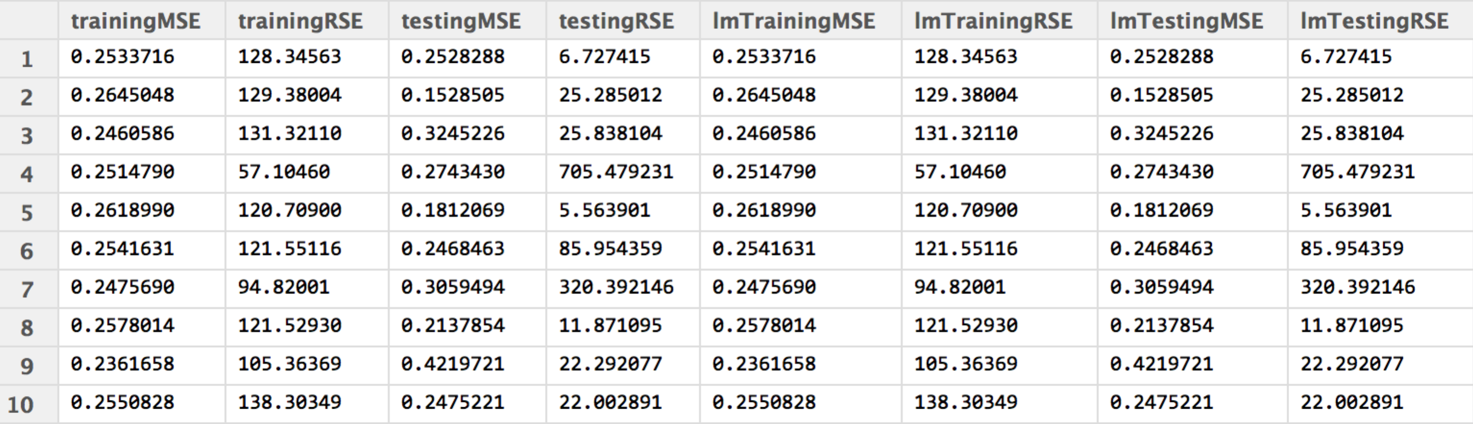

Data svar4 cubic model:

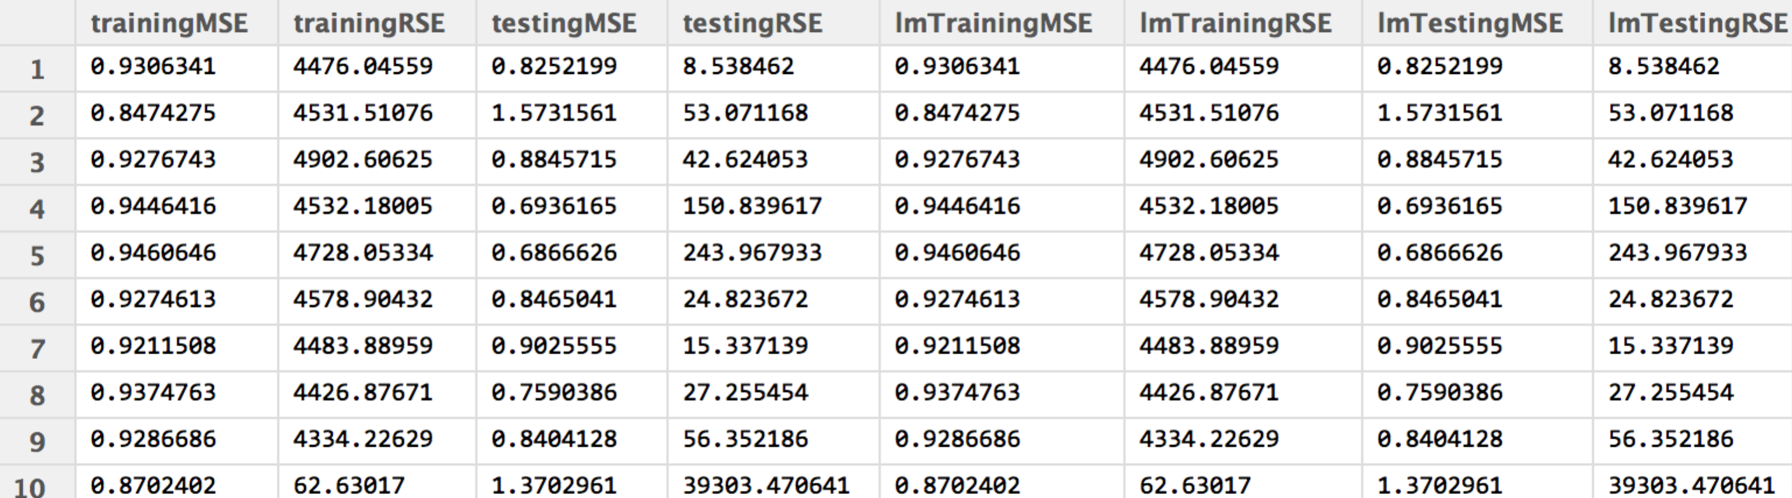

For the data set three and four, the errors are remarkably improved while using polynomial models.

4. Reduce data and observe how the performance will change.

I reduce the four training data sets by half.

Data svar1 linear model:

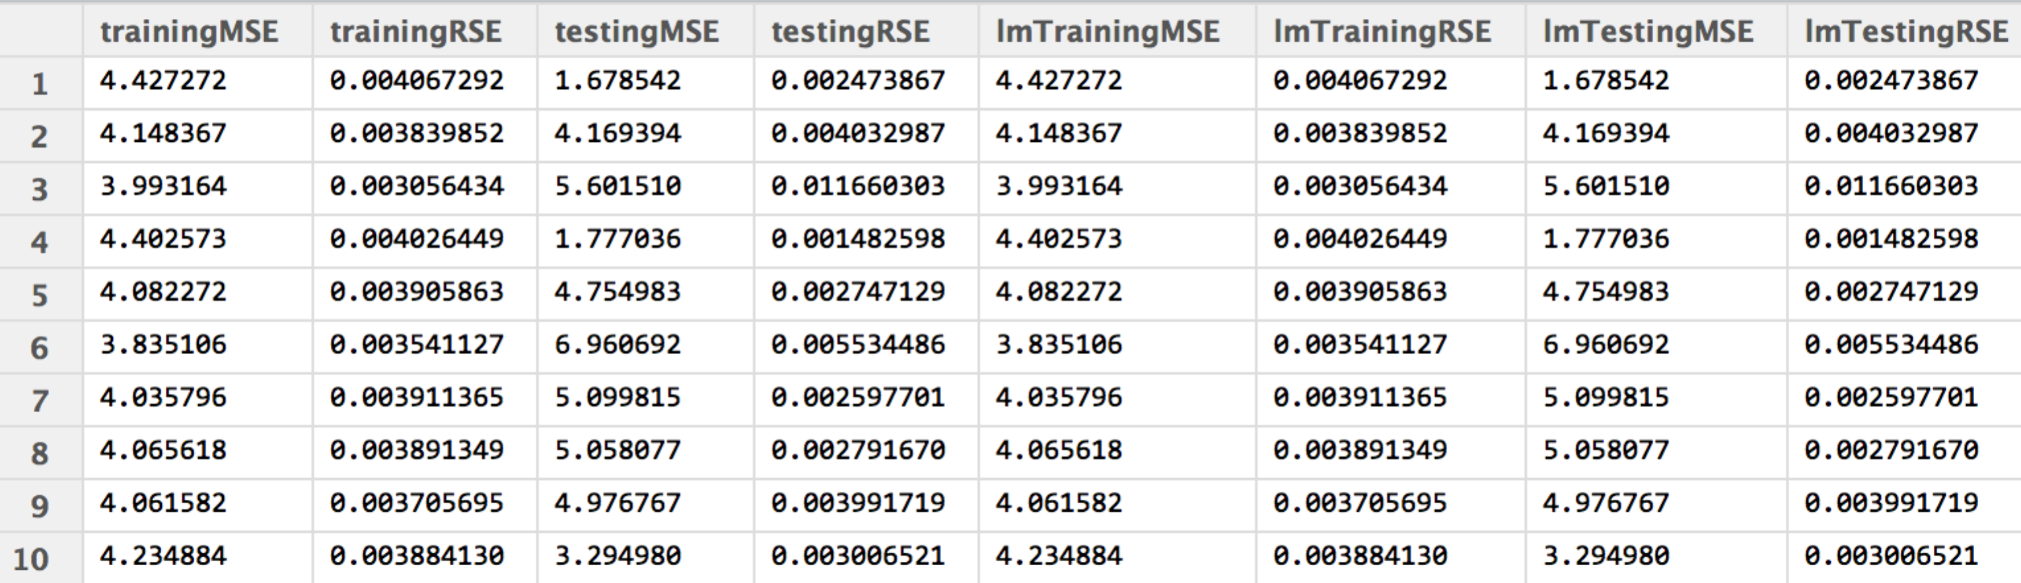

Data svar2 linear model:

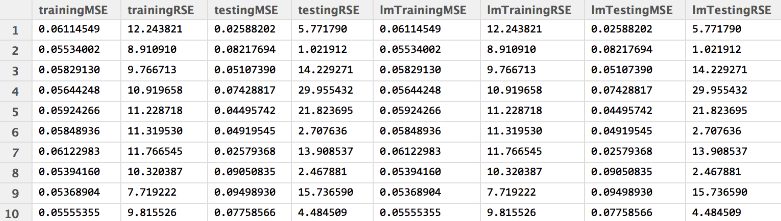

Data svar3 linear model:

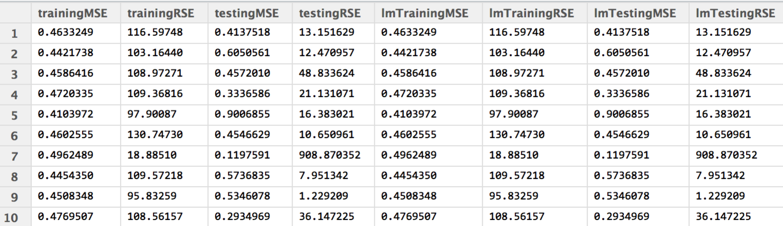

Data svar4 linear model:

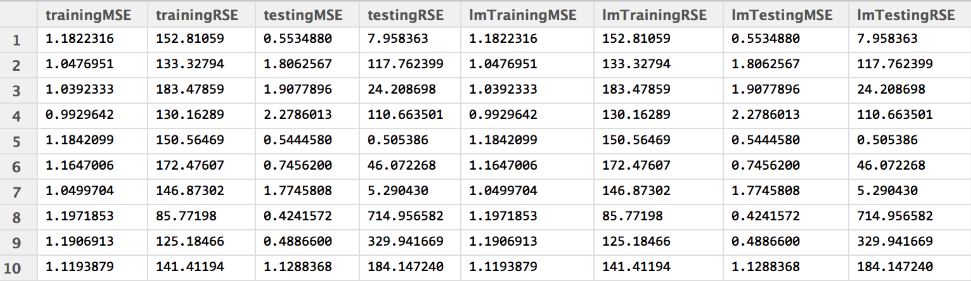

After reducing the input data, we can see most of recorded errors are greater than before.

***Multivariate regression***

1. Map the multivariate data sets to high dimensions.

Data mvar1 (15 out of 2500 observations):

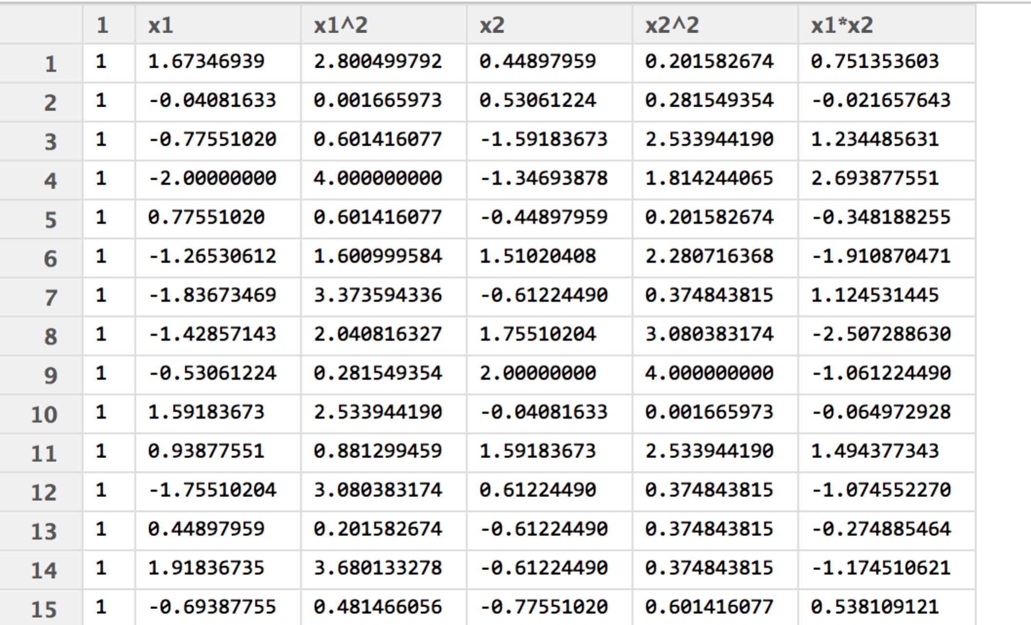

Data mvar2 (15 out of 2500 observations):

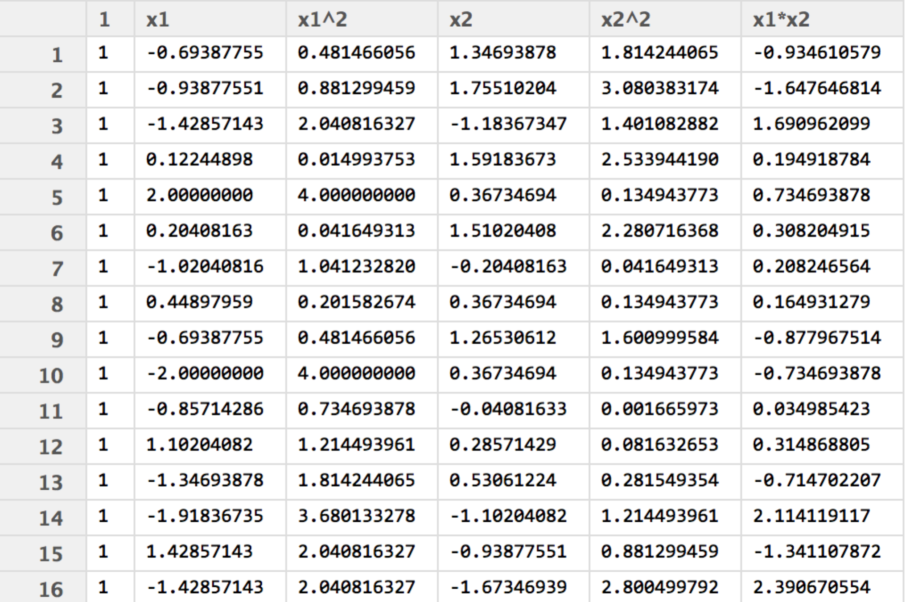

Data mvar3 (15 out of 100000 observations)

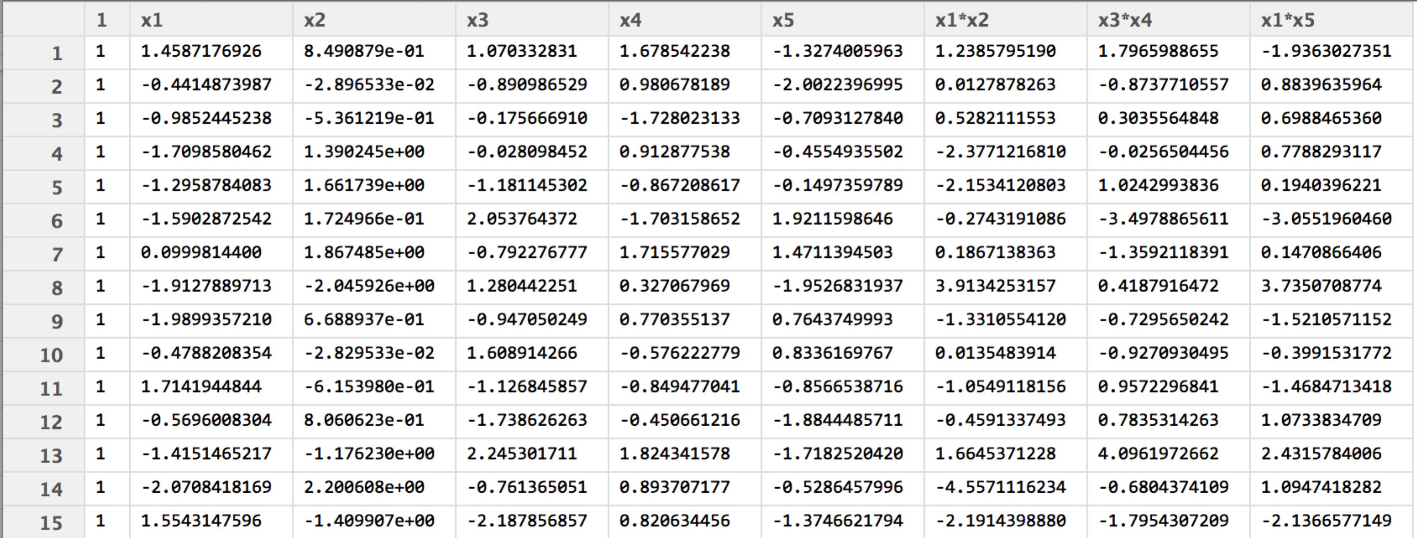

Data mvar4 (15 out of 100000 observations)

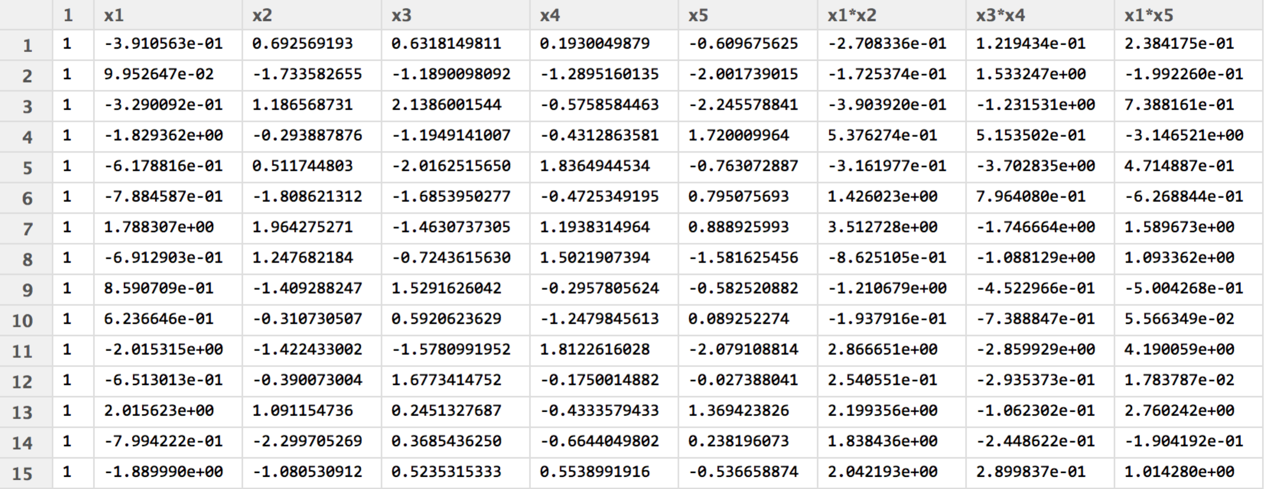

2. Perform linear regressions on these data sets.

I perform linear regression for each data set based on the high dimensional matrices I got (which are shown above). The training MSE and testing MSE are as follow.

Data mvar1:

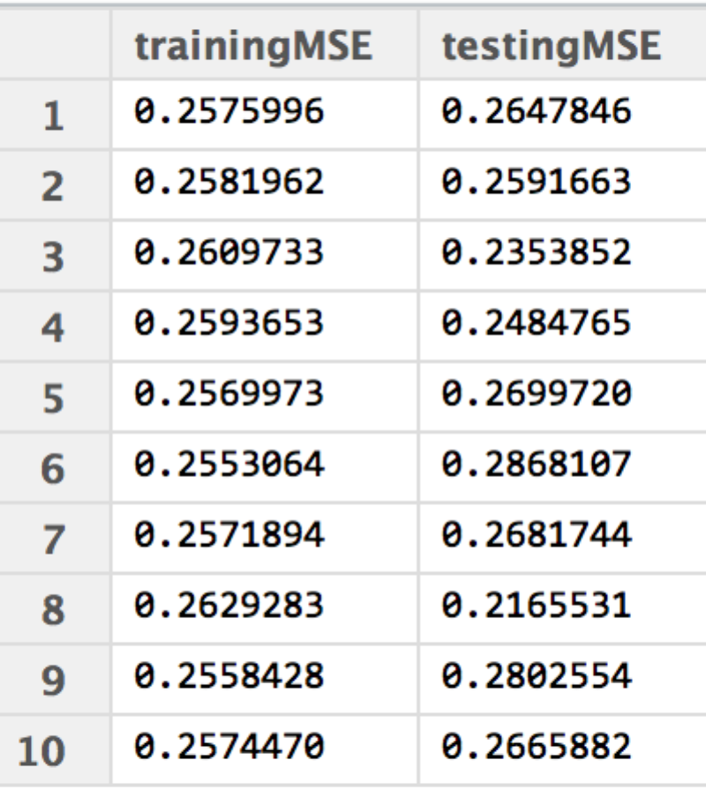

Data mvar2:

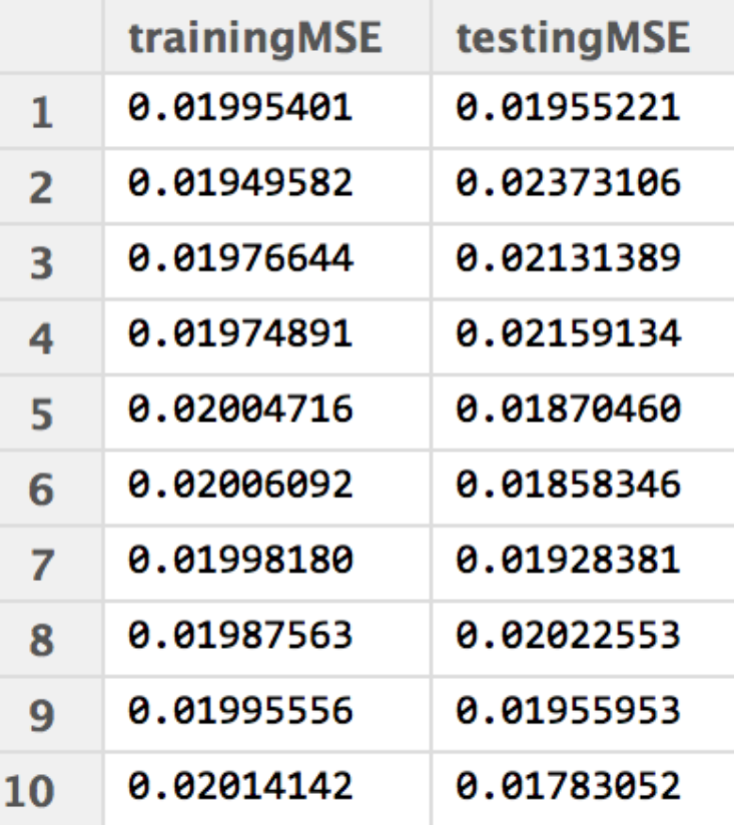

Data mvar3:

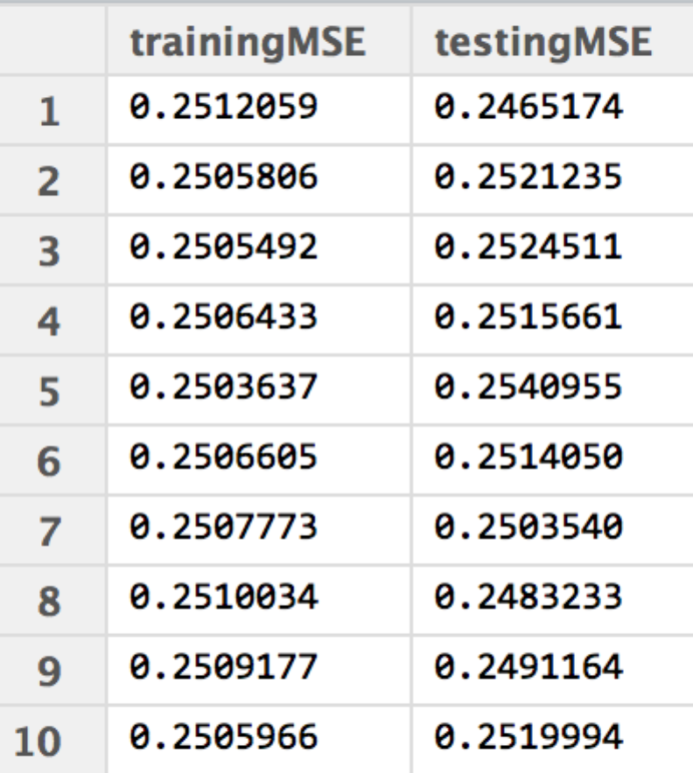

Data mvar4:

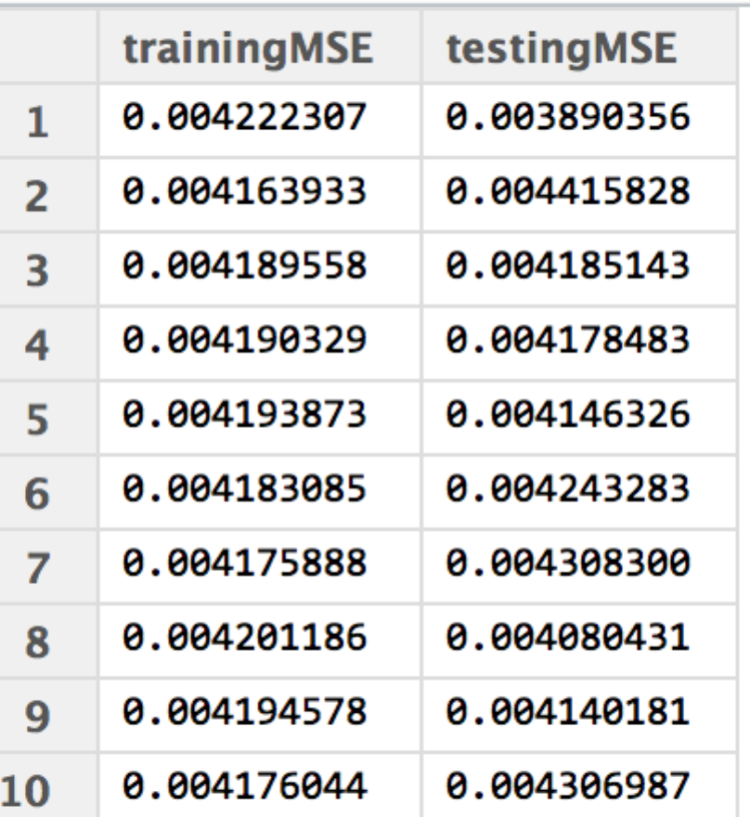

3. Implement an iterative solution and compare it with the explicit one.

I implemented the iterative solution by using the Gradient Descent Algorithm.

The results are as follow.

Data mvar1:

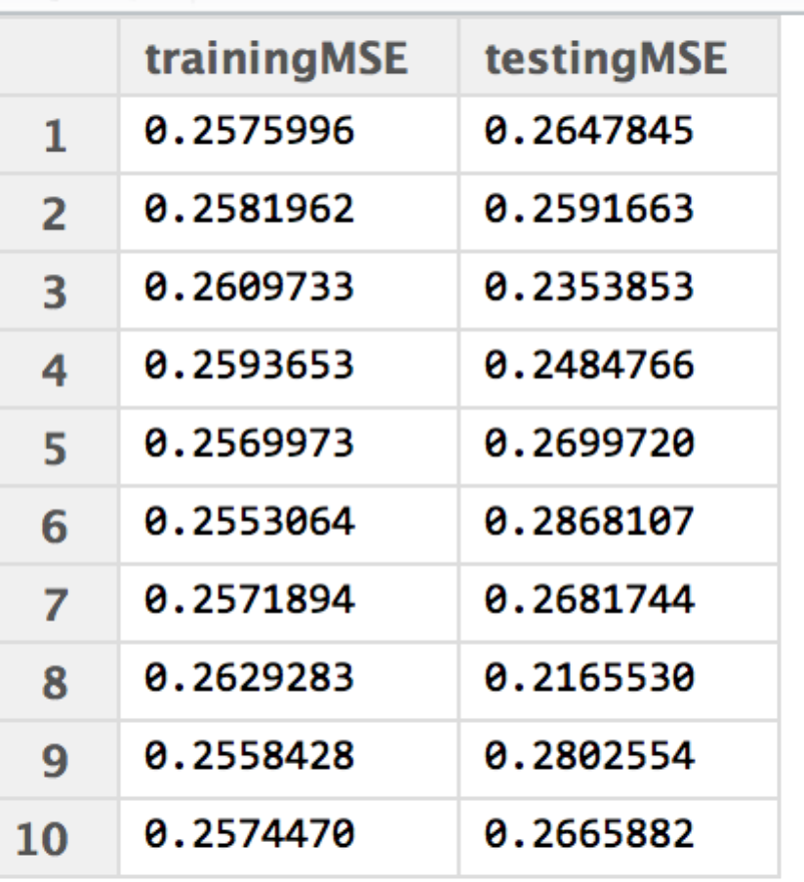

Data mvar2:

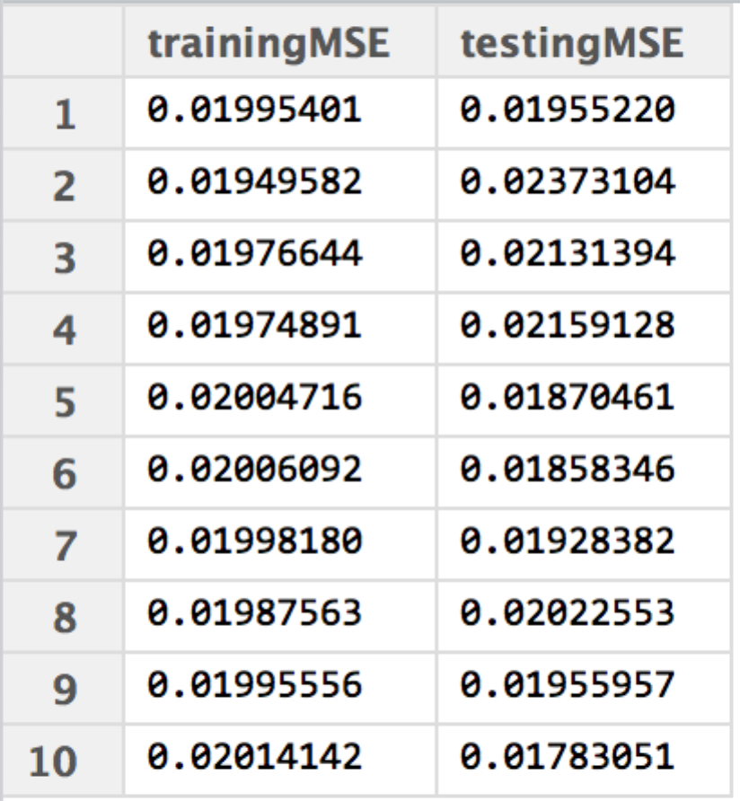

Data mvar3:

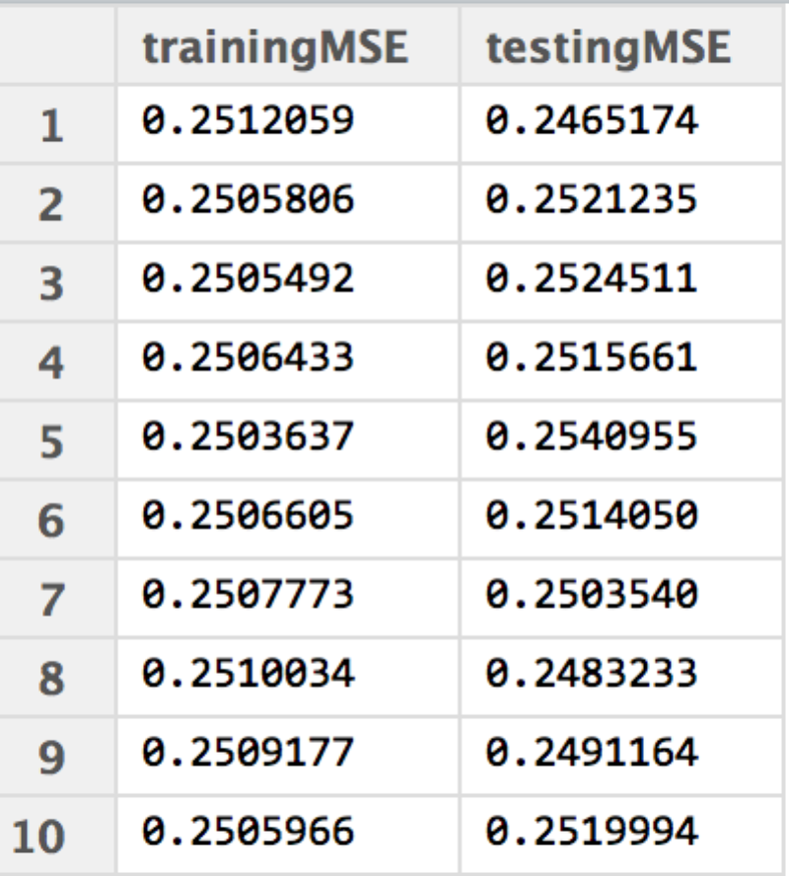

Data mvar4:

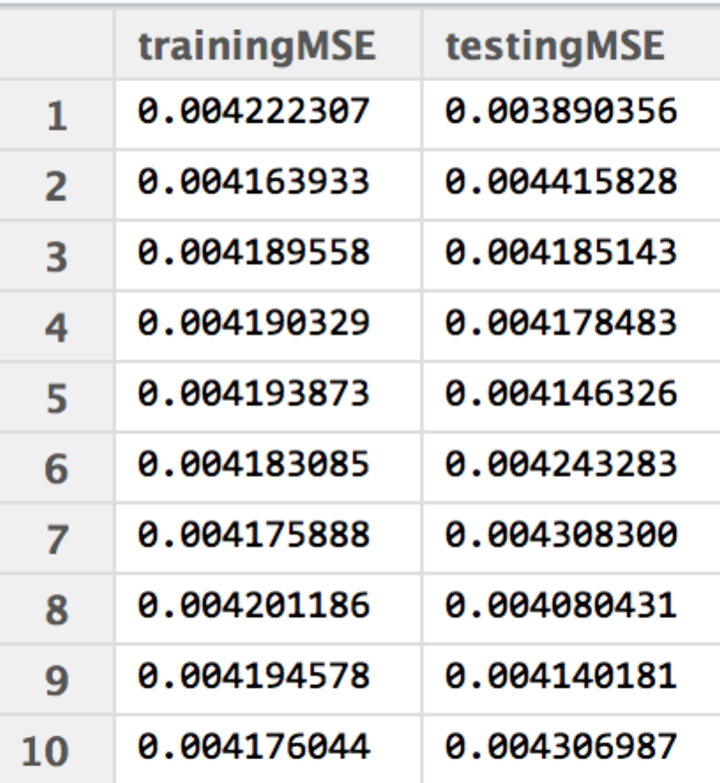

Compared with the explicit solution, the MSE of the two solutions are similar. However, when I was executing the gradient descent algorithm on the data sets “mvar3” and “mvar4”, I found it took much more time than I spent in running the explicit algorithm. Therefore, for sufficiently large data sets, we can’t ignore the running time if we choose to use the Gradient Descent Algorithm.